<FitUS>

Software Development Plan

Version <1.0>

Revision History

| **Date** | **Version** | **Description** | **Author** |
| --- | --- | --- | --- |
| <15/06/23> | <1.0> | <The initial version of the Project Plan> | <Team 104> |
|  |  |  |  |
|  |  |  |  |
|  |  |  |  |

Table of Contents

**1.** **Introduction 4**

**2.** **Project Overview 4**

*2.1* *Project Purpose, Scope, and Objectives 4*

*2.2* *Assumptions and Constraints 4*

*2.3* *Project Deliverables 4*

**3.** **Project Organization 4**

*3.1* *Organizational Structure 4*

*3.2* *Roles and Responsibilities 4*

**4.** **Management Process 4**

*4.1* *Project Estimates 4*

*4.2* *Project Plan 4*

4.2.1 Phase and Iteration Plan 5

4.2.2 Releases 5

4.2.3 Project Schedule 5

4.2.4 Project Resourcing 5

*4.3* *Project Monitoring and Control 5*

4.3.1 Reporting 5

4.3.2 Risk Management 5

4.3.3 Configuration Management 6

Software Development Plan

# 

# Introduction

The introduction of a **Software Development Plan** provides an overview of the document which builds a plan as a structural model**.** This document includes a purpose, scope, definitions, acronyms, abbreviations, references and overview of this project. Based on a project purpose and scope, this **Software Development Plan** synthesizes not only organization of role in project team, but also an abstract process in each phase of building project.

# Project Overview

## Project Purpose, Scope, and Objectives

* The purpose of this project is to admonish users to usually take care of their health based on features of this web application, which provide substantial parameters to easily manage their weight. Nowadays, people are usually overwhelmed with their work and daily life. As a consequence, health is an aspect that most people overlook. Thus, the demands for health checking are crucial, and so is FitUS.
* All individuals are the target audience since they have a significant need for health monitoring and attractiveness management. Users must be familiar with the fundamentals of utilizing website apps (sign in, create an account, etc.) in order to use this service.
* This service can consump in other applications such as Web browsers (Safari, Chrome, Microsoft Edge, Opera, Firefox, etc.). In development phase, this project be programming by using programming languages such as in Front-end included CSS, HTML, JavaScript/ TypeScript and in Back-end included ExpressJS (framework), JavaScript, MySQL/ Mongoose
* In this project, the objectives of it exist in both substance and mental for customers. It provides advice, an opinion and the statistics for users to have a different view about their health, about their fitness. Throughout the period using this application, customers will recognize the modification of their strength, their physical appearance which many statics and predictions this application provides.
* Base on the project’s purpose and objectives, the scopes of this project are:
* Health Record: Preserving a set of health statistics provided by the users.
* Health Monitoring: Illustrating charts and graphs representing users’ health conditions.
* Edit health records: Adding and updating personal health information.
* BMI calculator: Using your height and weight to determine the overall body weight is healthy or not.
* Food portion consultant: Providing users with appropriate diet plans. Therefore, helping the users achieve their ideal physique.

## Assumptions and Constraints

* There are 5 individuals on the team building this project, and no more will be added while it is in progress.
* Knowledge service in this project: Basic knowledge about Object-oriented programming, Frontend: Javascript/ HTML/ CSS, Backend: ExpressJS (framework), JavaScript, MySQL/ MongoDB.
* This project has a zero-budget
* Meeting schedule:
* Planning: Every first Monday of at 20:00
* Weekly Scrum: Every Friday at 20:00
* Review: Every last Saturday of two-week at 15:00
* Each role of each person can change during the project.

## Project Deliverables

Deliverables in each phase are identified in the Development Case.

# Project Organization

## Organizational Structure

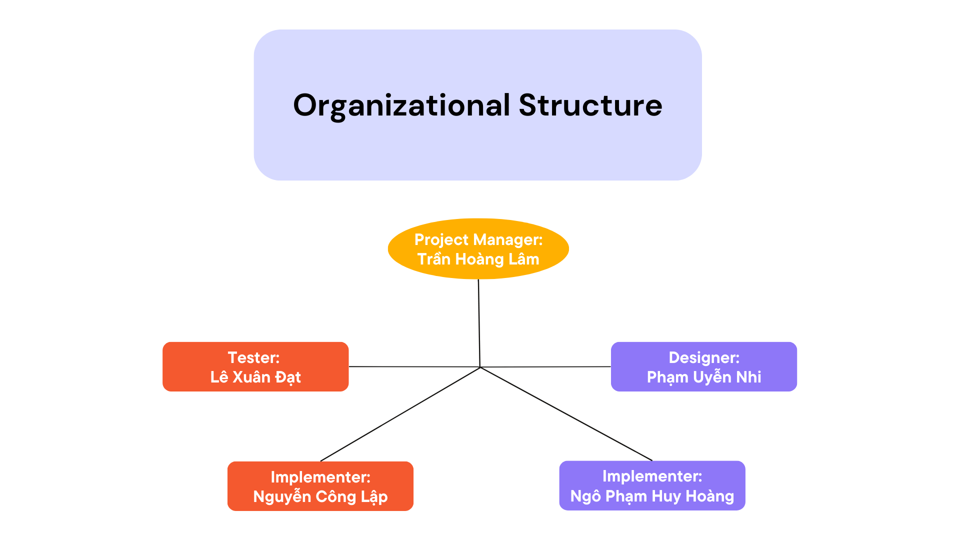

## Roles and Responsibilities

| **Person** | **Role** |
| --- | --- |
| Tran Hoang Lam  Pham Uyen Nhi  Nguyen Cong Lap,  Ngo Pham Huy Hoang  Le Xuan Dat | Project manager  Designer  Developer  Developer  Tester |

# Management Process

## Project Estimates

## Project Plan

### Phase and Iteration Plan

The project consists of 4 phases: Inception, Elaboration and Construction, Transition

* **Inception**: Week 1,2 (~Sprint 1):
  + Starting date: 11/06/2023
  + Ending date: 24/06/2023
  + Overall objectives: drafting initial versions of Project Plan and Vision Document.
* **Elaboration**: Week 3-6 (~Sprint 2,3):
  + Starting date: 25/06/2023
  + Ending date: 22/07/2023
  + Overall objectives:
    - Releasing revised versions of Project Plan and Vision Document.
    - Use-case document and use-case model.
    - Design document: defining software architecture in Software Architecture Document with class diagrams, designing the UI.
    - Preparing the test plan of the product.
* **Construction**: Week 7-10 (~Sprint 4,5):
  + Starting date: 23/07/2023
  + Ending date: 19/08/2023
  + Overall objectives:
    - Releasing revised version of Software Architecture Document.
    - Designing test cases and summarizing test results in the test report.
    - Releasing the first version of the product.
* **Transition**: Week 11,12 (~Sprint 6):
  + Starting date: 20/08/2023
  + Ending date: 02/09/2023
  + Overall objectives:
    - Filling in test summary report.
    - Implementing automated testing.
    - Releasing the second (final) version of the product.
    - Project presentation and product demo.

The Excel file in the ZIP file PA01 will contain the Gantt chart. (File excel name: GanttChar-Group104.xlsx)

### Releases

Throughout the project, there will be a total of 2 releases:

* The first one is planned to be released after the 5th Sprint (PA5) on August 19th, 2023
* The second one is planned to be released after the testing period in the 6th Sprint (PA6) on September 2nd, 2023. This is also the project’s final release.

### Project Schedule

| **Milestones** | **Finish Date** |
| --- | --- |
| *Finish Phase 1: Inception* | *24/06/2023* |
| *Finish Phase 2: Elaboration* | *22/07/2023* |
| *Finish Phase 3: Construction* | *19/08/2023* |
| *Finish Phase 4: Transition* | *02/09/2023* |
| *Release the first version* | *19/08/2023* |
| *Release the final version* | *02/09/2023* |

## Project Monitoring and Control

### Reporting

* Discord will be used for discussing the project (what should we do? programming language? ideas? etc) and reporting the project status weekly.
* Facebook will be used to ask some project-related questions to the TAs.
* Messenger will be used for frequently informal chatting.
* Azure Boards will be used for planning the tasks for each sprint, monitoring the state of each task (what to do? what is being done? what has been done? what should be done next? etc)

### Risk Management

*[Identify risks in your project. The risks should be prioritized, and shorted according to their priority.]*

| *Risk ID* | *Risk Description* | *Probability* | *Impact* | *Priority* | *Mitigation Strategy or Contingency Plan* |
| --- | --- | --- | --- | --- | --- |
|  |  |  |  |  |  |
|  |  |  |  |  |  |
|  |  |  |  |  |  |

### Configuration Management

* Google Drive: storing and sharing documents (like Software Development Plan document, Vision document, …) and project reports.
* GitHub: managing source code and related files.
* Discord: storing temporary code, ideas and conversations.
* Azure Boards: planning the tasks for each sprint (what to do? what has been done? etc)